perinatal peer mentoring project for women living with HIV

Terms of Engagement: Research with 4MNet

Aim: A clear statement of what each party needs to make the process work, understand what it takes to be involved, any support available, and aid overall preparation for the research

Definitions we are guided by:

The WHO consolidated guideline on SRHR of women living with HIV which was developed in collaboration with women living with HIV recommends that

“Research about women living with HIV should be conducted with, by and for women living with HIV, as equal research partners. Research that is pursued and funded in this area should include justification for why it is important to women living with HIV.” (6.2.1)

Involvement is respectful engagement with and learning from communities” -Meaningful involvement of women living with HIV and AIDS

Public involvement in research” is research carried out ‘with’ or ‘by’ members of the public rather than ‘to’, ‘about’ or ‘for’ them.”

Peer research is a participatory research method in which people with lived experience of the issues being studied, take part in directing and conducting research.

- What collaborators must consider (what things mean from 4MM’s perspective and what is expected from researchers at the point they express interest in collaborating)

- Budget and funding for the organisation and individuals getting involved. Including respectful remuneration. Funding is expected to be available for participants in line with NIHR guidance and for 4MM for their role. Fees to be determined based on work undertaken in addition to standard administrative fees
Payment
- 10% admin fee for 4M Net CIC
- Fee for Mentor Mothers as participants
- Fee for Mentor Mothers as Peer researchers
- Fee for Independent consultants coordinating the peer research process
Please see also the section below on suggested Remuneration, taken from: Guiding Principles for Public Involvement in SHARE Health Research.

- What is the definition of peer research and involvement for all parties involved? . (What type of activities 4MM will collaborate on, e.g, PPI, public engagement, qualitative research and expectation of collaborators and women involved )
- How can women be involved as equal partners?
- MOU and clarity on who is involved and what aspects of the project will be handled by whom based on capacity? What 4MM are willing to offer
- Skills and capacity building/training if required and the party responsible for the training
- Mentoring and support if required and what party will provide it?
- Use of clear, respectful and solution-focused positive language

- Why is this research important to women living with HIV?
- 4MM and women be appropriately acknowledged for their input and included as authors where the criteria for authorship have been met . Eg publishing, conferences and authorship
- Project management (Important elements that should be considered)
- Project timelines
- Fluctuating capacity of people that may be involved and backup plans .
- Ethics - For PPI and Public engagement research ethics would not be required. But for qualitative research and other research projects, this will be required prior to any research activities taking place

- As an MA student, what I wish I had done/known earlier:
- Anticipated the time commitment required of peer researchers. Peer research with a relatively high level of peer engagement (in keeping with MIWA principles) requires considerable time investment on the part of the peer researcher.
- Secured funding for the project. Ideally at the beginning of the academic year (September), potential funders could have been researched and contacted to see if funding was possible to pursue. The funding application may have taken months to be approved and funds may not have been available before the beginning of the research process, so starting the search as early as possible could have allayed for this.
- The research needs to have tangible benefit for 4MNet and peer researchers. Securing funding for peer researcher’s time and input would have been ideal. Publication in a journal may not be enough for this project.
- The Steering Group must be on board, and the project must be a source of enthusiasm for peer researchers.
- The need to understand the student’s responsibilities within the research process. Draw up a Memorandum of Understanding, stating what each party is going to do to make the process transparent and organised (like the Terms of Engagement but more formal).
- Respect the peer researchers’ time by providing deadlines of when work is to be sent for review. Contact peer researchers and inform them if a deadline will not be met but avoid doing so last-minute. Keep in regular contact with peer researchers (eg.once a week) and maintain regular communication. Don’t let things get stagnant; try and maintain momentum.

- As a peer researcher /4MNet
- Get the project team and steering group approval before a project starts and be aware that they may need to review some of the work so make provision for that as well as provide credit/authorship where necessary.
- Both parties need to understand the definition of involvement in research so as to work together to ensure that is what is actually happening. It can be time-consuming as such each party should be prepared for it
- Be aware of the time it can take to write the preliminaries of research prior to recruiting women /arranging suitable interview dates as well as how lengthy the recruitment process can be.
- Be aware of the possibility that people can opt out or suddenly be unavailable as such, always recruit more than the number you actually need
- Be aware of the level of commitment required for the project and what will be realistic considering each person’s real and not perceived capacity. Have ongoing conversations to check in and make necessary changes as capacity and availability can fluctuate. Have back up plans
- Have mentoring in place from the project team to support the peer researchers involved (make paid time available for the peer coordinator)
- Be aware that women might want to get involved in varying degrees and where possible, have bite-size involvement opportunities so that it can provide opportunities for all
- Ask for all contributors’ availability and provide advance notice of when draft content will be sent for review, so that time is blocked off also in advance
- Secure funding for involvement in research to pay people for their time. It is a valuable skill and women should be rewarded as experts/ Peer researchers
- Understand that collaborative work takes a lot of commitment to ensure deadlines are met. As such, any delays in an individual’s time might impact collective achievement of the work.
- Be aware it will be important to work as a team and support each other. If a person is struggling let the team know to avoid holding the work up
- Be aware the more people involved, the longer it will take to get responses. Make ample time available.
- Carry out a skills audit before the research starts and provide necessary training and support to enable women get involved as peer researchers so that they can effectively contribute (include literature review, data collection analysis, publication etc)
- Provide digital support (data, call time, telephone and recorders if required as well as qualitative software for analysis) to enable women participate without being out of pocket
- Have clear tangible benefits and outcomes of research so that women see what effect their involvement has for their lived realities.
- Publish in journal articles to strengthen evidence base and effect policy changes as much as possible.
- Decide reference credit/authorship based on the level of involvement of each author
- Be aware of ethics, confidentiality and GDPR.
- As good practice pilot interviews and review before they are administered.
- Be clear about roles and responsibilities in the MOU including the aspects of research the researcher will be responsible for, those Women are responsible for and the ones both will work on as a team

- Other issues
Keep collecting and recording any learning experiences to make the process easier in the future.

- Contributors
Longret Kwardem
Laura Pulteney
Laurette Bukassa
Angelina Namiba

Additional Resources

Remuneration of public participation and involvement in research
This section is taken from: Guiding Principles for Public Involvement in SHARE Health Research.
The public can either participate in research as participants (as primary sources of data) or be involved as active research team members such as peer or community researcher. In both circumstances, remuneration must consider their level of involvement in the research project and, where appropriate specific skills are required.
There is no harmonised approached of public remuneration in research, however, it is best to have a clear payment and recognition policy in place so that the public is aware of what is being offered prior to participation so that they can make an informed decision on whether to participate. Principles of remuneration are transparency and communication.
Lynch et al (2021) developed a framework to consider when remunerating public participation or involvement in research by distinguishing reimbursement, compensation, and incentive in the table below:
Reimbursement | Compensation | Incentive
Goal
Full coverage of reasonable expenses | Fair payment for time and burden | To encourage enrolment and retention in important and ethical research of participants for whom reimbursement and compensation are insufficient motivations
Variability
Amounts will vary per participant depending on expenses incurred | Rates should be uniform across participants | Aim for uniformity across participants and offer after completion.
Coverage
May include transport to and from visits, meals, accommodation | Amount of time spent in the research activity | Amount needed to motivate participants
Factors to consider
Pre-payment (vouchers) or refund of out-of-pocket expenses | Duration, impact of research activity | Study importance and urgency of recruitment, study budget, type of participants sought.
Relevant benchmarks
Reimbursement rates and incurred costs with receipts | Payment in comparable research | Incentives offered in other similar research, institutional requirements, uniformity within acceptable range across various research projects

The NIHR developed the Payment guidance for research and professionals that highlights rates for honorarium payments to public involvement in research depending on the task and time spent:
Task | Estimated time spent to complete task | Rate
Reading and commenting on an abstract | <30 minutes | £12.50
Activity requiring little or no preparation such as participating in a focus group discussion | ≤1 hour | £25.00
Activity likely to require some preparation such as the need to read papers or review a few short documents | Approx 2 hours | £50.00
Activity likely to require some preparation such training delivery | Approx half a day’s work | £75.00
Involvement in all-day meeting such as attending a committee or panel meeting as an observer prior to becoming an active public member of a committee/panel. | All-day | £150. 00
For involvement in meetings that require substantial preparation such as chairing or co-chairing a meeting | All-day | £300.00

This guidance can be adapted depending on the institution and context and the role (and rate of pay) of the public or community partners.

Below is a SHARE example of time allocated to collaborative tasks in the one of our studies

TASK | ESTIMATED TIME | TOTAL TIME (hours)
Read documents for ethics submission | 3 hours | 3
Ethics committee attendance and preparation | 2 hours | 2
Reviewing study materials | 1 day (8 hours) | 8
Advisory group meetings attendance and preparation – 2x/year | 3 hours/meeting = 6 hours/year for 3 years | 18
Attending peer researcher training | 1 day (8 hours) | 8
Supervising peer researchers | 3 hours every month for 1 year | 36
Results workshop x 2 and preparation | Each workshop + preparation is 4 hours | 8
Results dissemination – assistance with writing lay reports | 1 day (8 hours) | 8
Reviewing academic papers/ conference presentations | 2 days (8 x 2 hours) | 16

NOTE: We will strive for equity and transparency with all our collaborators. These payment guidelines are our ‘ballpark’ standards; will consider the circumstances of each individual or organisation and the adequate amount of time spent on the given task, based on skill and expertise where appropriate.
Fig 1: Tree of Participation International Community of Women Living with HIV -2004 https://salamandertrust.net/wp-content/uploads/2016/09/13ICWWECARE_Policy-briefing_ENGDakarSep2013.pdf
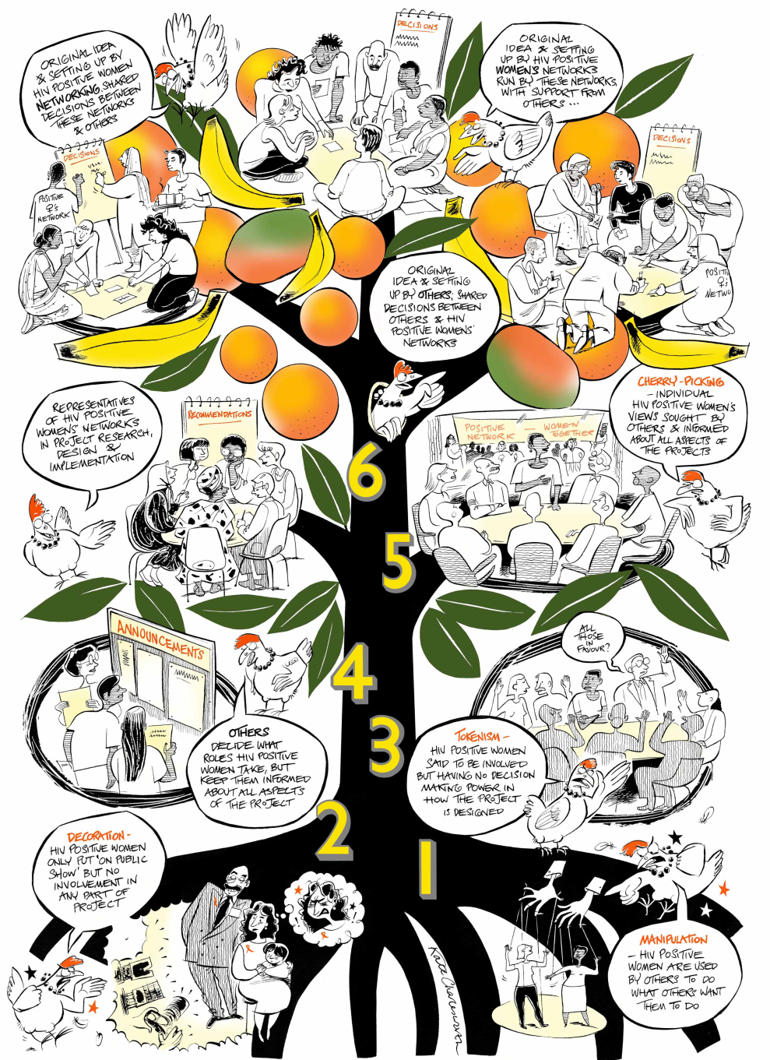
Near the base of the trunk, decisions are made solely by others. Women/girls living with HIV have no role in decision-making. Further up the trunk, decisions are made by others with advice from Women/girls. At the top of the tree, where you will find the fruit, there is a real working partnership

WHO Consolidated Guideline on Sexual and Reproductive Health and Rights of Women living with HIV (2017) https://tinyurl.com/WHOSRHR17?
Namiba A., Orza, L., Bewley, S., Crone, E. T., Vazquez, M., & Welbourn, A. (2016). Ethical, strategic, and meaningful involvement of women living with HIV starts at the beginning. Journal of virus eradication, 2(2), 110–111.
National Institute for Health Research (2021) Briefing notes for researchers - public involvement in NHS, health and social care research https://www.nihr.ac.uk/documents/briefing-notes-for-researchers-public-involvement-in-nhs-health-and-social-care-research/27371
Lushey, C.(2017) ‘Peer Research Methodology: Challenges and Solutions’ [Online]. Survivor Involvement Ladder https://survivorsvoices.org/involvement-ladder/ [Online]
National Institute for Health Research (2021) Payment guidance for researchers and professionals https://www.nihr.ac.uk/documents/payment-guidance-for-researchers-and-professionals/27392
Lynch, Holly Fernandez, et al. "Promoting ethical payment in human infection challenge studies." The American Journal of Bioethics 21.3 (2021): 11-31.
https://www.nihr.ac.uk/documents/payment-guidance-for-researchers-and-professionals/27392

